- Install Intellij IDEA 14.1 https://www.jetbrains.com/idea/download/
- Run Intellij IDEA 14.1 -> Create Maven project
- Open pom.xml file and add dependencies

Links for updating dependencies for Maven:

- Selenium 2.0 = Selenium 1.0 + WebDriver
http://www.seleniumhq.org/download/maven.jsp
<dependency>
<groupId>org.seleniumhq.selenium</groupId>
<artifactId>selenium-java</artifactId>
<version>2.45.0</version>
</dependency>

- JUnit
https://github.com/junit-team/junit/wiki/Download-and-Install
<dependency>
<groupId>junit</groupId>
<artifactId>junit</artifactId>
<version>4.12</version>
<scope>test</scope>
</dependency>

- TestNG
http://testng.org/doc/maven.html
<dependency>
<groupId>org.testng</groupId>
<artifactId>testng</artifactId>
<version>6.1.1</version>
<scope>test</scope>
</dependency>

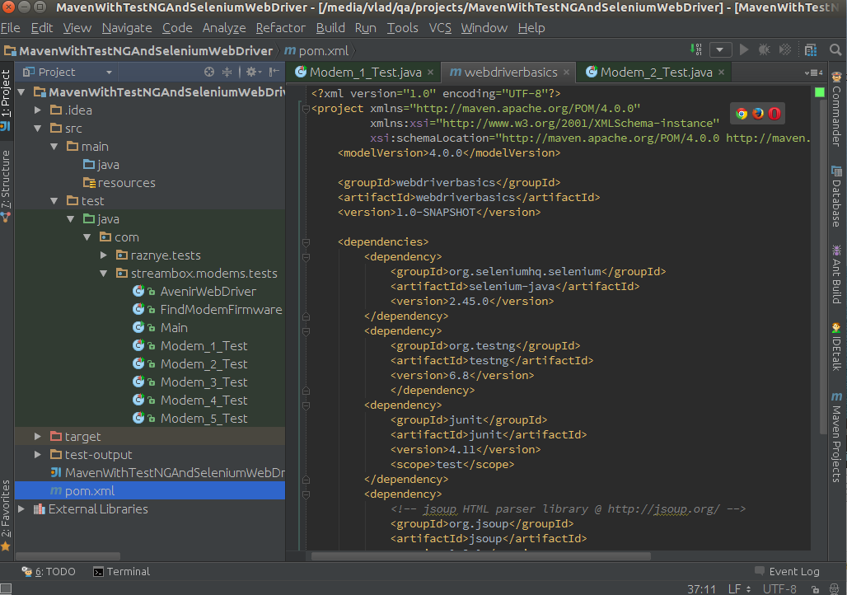

original .pom file from my project

<dependencies>
<dependency>
<groupId>org.seleniumhq.selenium</groupId>
<artifactId>selenium-firefox-driver</artifactId>
<version>2.45.0</version>
</dependency>
<dependency>
<groupId>junit</groupId>
<artifactId>junit</artifactId>
<version>4.11</version>
<scope>test</scope>
</dependency>
<dependency>
<groupId>org.testng</groupId>
<artifactId>testng</artifactId>
<version>6.1.1</version>
<scope>test</scope>
</dependency>

<!--For WebDriverWait-->
<dependency>
<groupId>org.seleniumhq.selenium</groupId>
<artifactId>selenium-java</artifactId>
<version>2.45.0</version>
</dependency>
</dependencies>

